Analysing individual specialisation and flexibility in predator hunting mode and its effect on hunting success using an online multiplayer videogame

Maxime Fraser Franco1, Francesca Santostefano1, Clint D. Kelly1, Pierre-Olivier Montiglio1

###### Groupe de Recherche en Écologie Comportementale et Animale (GRECA), Département des Sciences Biologiques, Université du Québec à Montréal, Montréal, QC, Canada

###### 1Correspondence: Pavillon des Sciences Biologiques (SB) SB-1805, 141 Avenue du Président-Kennedy, Montréal (Québec), Canada, H2X 1Y4

###### 1Corresponding author: maxime(dot)fraser(dot)franco(at)hotmail.com

# Abstract

This is my abstract paragraph

Keywords: individual variation, hunting success, foraging mode, hunting tactics, predator-prey behaviour, online videogames

# Introduction

Predator hunting mode plays a crucial role in structuring ecological communities and ecosystems (Huey & Pianka 1981; Preisser *et al.* 2007; Schmitz 2008; Kersch‐Becker *et al.* 2018), and usually consists of three main classes: 1) active/cursioral hunters who search, follow, and chase prey for long distances, 2) sit-and-pursue hunters who remain motionless and pounce on prey that are within chasing distance, and 3) sit-and-wait/ambush hunters who wait for prey to be within immediate capture distance (McLaughlin 1989). Field studies show that predators with contrasting hunting modes (e.g. cursorial vs ambush) can cause opposing trophic cascades and act at different trophic levels (Schmitz 2008; Romero & Koricheva 2011). For instance, predators might differ in the number of individuals or species, or in the type of prey that they capture relative to their hunting mode (Miller *et al.* 2014; Donihue 2016; Glaudas *et al.* 2019). Such observations sparked a growing interest in investigating how ecological factors shape individual variation in hunting behaviour within populations, and its consequences for predator-prey interactions (Pettorelli *et al.* 2015; Toscano *et al.* 2016; Schmitz 2017). Indeed, studies report that individual predator behavioural type can mediate consumptive and nonconsumptive effects during trophic interactions (Smith & Blumstein 2010; Griffen *et al.* 2012; Toscano & Griffen 2014). However, predator species still tend to be classified either as active or sit-and-wait hunters based on their average behaviour (Lima 2002; Miles *et al.* 2007; Pettorelli *et al.* 2015; Schmitz 2017). It is therefore imperative that we account for individual variation in hunting mode during predator-prey interactions if we hope to understand community-level consequences of predation.

Individual variation in hunting mode can be driven by specialisation when predators in a given population display consistent differences in tactic use. Such differences are expected when individuals experience temporal and/or spatial fluctuations in the distribution, availability, or behaviour of their prey (Araújo *et al.* 2011; Carneiro *et al.* 2017; Phillips *et al.* 2017; Courbin *et al.* 2018). For example, predators specialise in specific tactics to meet the energy/time demands that are required to successfully capture the type of prey generally encountered (Bowen *et al.* 2002; Tinker *et al.* 2008; Arthur *et al.* 2016). Prey activity/mobility is an important trait influencing encounter rates with predators (Gerritsen & Strickler 1977; Huey & Pianka 1981; Scharf *et al.* 2006). Therefore, individual variation in encounter rates with prey activity-types may lead to nonrandom interactions between predator-prey behavioural types (Wolf & Weissing 2012). Such a mechanism in trophic interactions is described by the locomotor-crossover hypothesis (Huey & Pianka 1981), which predicts that ambush predators should be more successful when they hunt fast-moving prey, while cursorial predators should have greater success with sedentary prey (Scharf *et al.* 2006; Belgrad & Griffen 2016; Donihue 2016). (retravailler cette phrase)If individual tactics allow predators to reach similar capture rates, then predators with contrasting hunting modes might coexist within a population (Kobler *et al.* 2009; Michel & Adams 2009; Chang *et al.* 2017). However, this hypothesis could be difficult to test at the individual level in wild populations of free-ranging predators.

Habitat structure is a second important driver of individual differences in predator foraging mode, as it shapes opportunities for prey encounter and prey capture (Robinson & Holmes 1982; James & Heck Jr. 1994; Sargeant *et al.* 2007; Wasiolka *et al.* 2009; Donihue 2016). A growing body of evidence points to predators who hunt in open and homogeneous habitats adopting a cursorial strategy, contrary to those hunting in heterogeneous and closed habitats that typically ambush their prey (James & Heck Jr. 1994; Wasiolka *et al.* 2009; Donihue 2016). Hence, the habitat components of a predator’s hunting grounds can predict the tactic used. Heterogeneous habitats are expected to favor sit-and-wait/sit-and-pursue hunters as they offer perches and cover, which are useful for ambushes (James & Heck Jr. 1994; Laurel & Brown 2006). On the contrary, active hunters should benefit from higher encounter rates in open habitats as prey detection is easier, but at the expense of being themselves more easily detected (Michel & Adams 2009). This suggests that tradeoffs could mediate individual differences in hunting strategies as a function of habitat structure. In this sense, predators could benefit from adjusting their strategy in accordance with short-term prey and habitat changes.

A wide range of predator taxa display flexible hunting behaviour (Helfman 1990; Heithaus *et al.* 2018). Foraging mode-switching occurs when individual predators respond to prey or habitat changes within their lifetime to maintain optimal hunting success. Notably, foraging mode switching can be triggered as a function of prey density (Inoue & Marsura 1983), prey behavioural type (McGhee *et al.* 2013), prey condition (Wignall & Taylor 2008), seasonality (Miles *et al.* 2007; Phillips *et al.* 2017), or in response to changes in habitat structure (Wasiolka *et al.* 2009). Despite our improved knowledge of what triggers foraging mode-switching, most research is conducted under controlled laboratory conditions, which can fail to capture the nuances and complexities of predator species’ ecology in the wild (Carter *et al.* 2013; Niemelä & Dingemanse 2014). Understanding how and when predators balance specialisation vs switching in tactics, and how these changes affect hunting success would help scientists to predict more precisely the community consequences of predation.

Empirically investigating individual variation in hunting mode requires repeated measures of behaviour of numerous individuals under different environmental settings (Dall & Griffith 2014; Dingemanse & Wright 2020). Such an approach may impose considerable financial, technical, and ethical challenges when studying larger or elusive wildlife, such as apex predators (Hertel *et al.* 2020). An additional challenge in empirical studies of predator-prey interactions is identifying traits in predators and prey that are easily observable, but also ecologically relevant. For instance, foraging mode is expected to vary along a continuum of morphological, physiological, and behavioural traits (Perry *et al.* 1990; Perry 1999; Butler 2005; Cooper 2005; Miles *et al.* 2007), but few studies have investigated how habitat- and prey-specific caracteristics jointly shape individual variation in correlated foraging traits.

Here, we propose a novel approach to combat the challenges of studying individual variation in predator behaviour that capitalizes on online multiplayer videogames (Balicer 2007; Lofgren & Fefferman 2007; Oultram 2013; Ahmad *et al.* 2014; Ross *et al.* 2015). Online multiplayer videogames could provide numerous opportunities for ecologists to study general ecological phenomena, including the mechanisms driving individual variation in behaviour (Barbe *et al.* 2020). First, online videogames provide innumerable repeated measurements from millions of individual players across temporal and environmental gradients, which would be impossible with traditional field studies. Second, environmental settings are known and can be manipulated by the observer, thus permitting experimental tests of how specific environmental components shape the behaviour of interest. Third, videogames can realistically reproduce ecological settings in which complex among-individual interactions occur. A classic example of this approach is the analysis of the “Corrupted Blood” epidemic in *World of Warcraft*, where precise epidemiological parameters, such as transmission rate, were used to predict the outbreaks (Balicer 2007; Lofgren & Fefferman 2007). In this sense, online multiplayer videogames potentially constitute a complement to traditional field studies. We suggest that they will permit ecologists (among other scientists) to bridge the gap between real-world ecological studies and large-scale computer simulations. Online videogames are of interest to social, economic, and epidemiological sciences (Ross *et al.* 2015), but to our knowledge, ours is the second study (see Cere et al., accepted) to use an online videogame to test ecological hypotheses.

We used the online multiplayer videogame *Dead by Daylight* (*DBD*) as our study system. This game pits a single player (predator) against a group of four players (prey), where the predator’s objective is to capture prey (Fig. 1). The predator’s main objective is to search for and consume prey, while the preys’ objective is to escape the predator. Prey can use a wide range of behaviours such as cooperation or hiding to successfully escape (Fig. 1 B and C). For example, they can cooperate to help conspecifics escape from capture (Cere et al., accepted), which predators may exploit to lure them in an ambush. These situations offer the possibility for predators to express different hunting tactics. Moreover, each match in *DBD* occurs within a specific game environment. The different game environments vary from forests, to farmlands, to urban areas. These environments differ in the heterogeneity and complexity of their structures (McCoy & Bell 1991), such as in the availability of perches and refugia, vegetation density, or surface area (Fig 1. D). Hence, predators may encounter prey that express different behaviours, and are expected to benefit from changing their behaviour accordingly to maximize hunting success.



**Figure 1. Images of the online videogame Dead by Daylight** **A)** The predator player’s first person vision. **B)** The prey (survivor) player’s third person vision. Prey can cooperate to repair generators. Once all generators are repaired, prey may activate one of the two **C)** doors in order to escape and win the match. **D)** Representative pictures of the different game environments where matches take place. The game environments settings vary between urban, farmland, and forest areas.

In this study, we used an extensive and complete dataset on the hunting behaviour of predator players in *Dead by Daylight* to investigate environmental and individual variation in hunting mode, and how it affects hunting success. We used four hunting-related behaviours as proxies of hunting mode: travel speed, the rate of space covered in the environment, the proportion of time spent in an ambush position, and the time before first capture. We applied the conceptual framework of behavioural syndrome analysis, which provides a means to quantify variation in multiple behaviours and their correlations at different hierarchical levels (Dingemanse & Dochtermann 2013). Thus, we quantified population and within-population structure/variability of predator foraging mode along a continuum of hunting traits (Perry *et al.* 1990; Perry 1999; Butler 2005; Cooper 2005; Miles *et al.* 2007). Environmental variation at the population-level includes among-habitat differences in average hunting behaviour. Within-population variation includes a) the variation in tactic use arising when some individuals use one tactic more often than the others (i.e. individual specialisation) and b) the variation arising from individuals adjusting tactic use over time in response to changes in environmental conditions or prey behaviour (i.e. individual flexibility). First, we hypothesized that predators would use hunting tactics according to habitat-specific characteristics. Therefore, we expected correlated trait values associated with ambush tactics in smaller and heterogeneous environments, and correlated trait values associated with cursorial tactics in open/wider and homogeneous environments. Second, we hypothesized that individual predators would consistently differ in their hunting mode over time, with some specialising as cursorial hunters, and others as ambush hunters. Thus, we predicted that individual predators would differ in their average trait values along a continuum for all combinations of the four hunting traits (among-individual behavioural correlations). Following the locomotor-crossover hypothesis, we predicted that ambush and cursorial predator-types may coexist in the population, because both achieve similar hunting success by performing better against prey with the opposite locomotor tendency. Lastly, we hypothesized that individual predators would express flexible hunting behaviour, by switching from cursorial to ambush tactics between foraging bouts. We predicted that the individuals’ residual trait values in contrasting hunting behaviours (ambush vs cursorial) would be negatively correlated (within-individual behavioural correlations).

# Materials and methods

## (a) Study system

The datasets used to test our hypotheses were provided by Behaviour Interactive Inc., the creator and administrator of *DBD*. The company records the behaviour of players for every match played online. During our study period, *DBD* offered 15 playable predator avatars. Players who incarnate the predator choose their avatar before a match takes place. Each predator avatar has unique abilities that may encourage different playstyles. Some have abilities than make them stealthier, while others can run faster, or have more powerful attacks. We thus controlled for the chosen avatar in our models since it may impact the playstyle of the predator player. In addition, the game environment where players compete is usually randomly assigned from a list of 27 maps differing in their physical components. For example, some maps have large playable surface areas with low vegetation density, which may favor the use of a cursorial strategy. Other maps have a smaller surface area with high vegetation density, which may impair visibility and alter prey detection, favoring the use of an ambush strategy. For additional details on the game settings and map characteristics, refer to <https://deadbydaylight.com/en>, and <https://deadbydaylight.gamepedia.com/Dead_by_Daylight_Wiki>.

## (b) Data collection

The study period ranged from March 20 to June 17 2019. Our population consisted of 2 171 new anonymous players who initiated their first match between March 20 and March 22, with a total record of 70 831 matches (average: 177 matches, range: 1 - 972 matches). Matches lasted for an average of 11 minutes (range: 5 - 58 minutes). For each match, we recorded the date (date-hour-minutes), the duration, the predator player’s anonymous ID, the prey players’ anonymous ID’s, the predator’s avatar, and the game environment where the match took place. We also recorded predator and prey behaviour (see next section ‘Behavioural traits’). We retained matches that lasted more than 5 minutes (short matches are usually interrupted because of technical issues). Players also score points during a match by performing different actions. To control for matches where players did not play, or for errors in the data collection, we removed matches where predators earned less than 1 point.

## (c) Behavioural traits

### (i) Predator hunting behaviour

We selected four out of eight behavioural variables that summarize most of the variation in predator hunting tactics based on a principal component analysis (see Fig. S1 and Table S1 in Supporting information for details on this analysis): travel speed (meter/sec.), the rate of space covered (square/sec), the proportion of time spent in an ambush position during the match, and the proportion of time the predator took to capture his first prey (see section ‘Behavioural traits measurements’ in Supporting information for details on the measurements). Individual predators using a cursorial tactic should exhibit greater average travel speed and rate of space covered with a lesser amount of time before a capture, whereas those using a sit-and-wait/pursue tactic should be slower, spend a greater proportion of their time in an ambush position, and take longer before capturing their first prey.

### (ii) Prey behaviour

We quantified the travel speed (meter/sec.) of prey and their rate of space covered (square/sec.). These two traits were measured using the same method described for predators (see description in Supporting information). For both traits, we averaged the four individual prey values within each match since we were interested in the average effect of prey behaviour on the predator’s hunting behaviour. Thus, we used one average value per prey trait, for each match played.

## (d) Statistical analyses

We performed all statistical analyses using the R software (version 4.0.2, R Core Team, 2020) on a remote computer cluster (Cedar, Compute Canada, <https://docs.computecanada.ca/wiki/Cedar>) running on CentOS Linux 7. All models were fitted using the R package “brms” version 2.14.4 (Bürkner 2017).

### (i) Variation in hunting mode

We first parametrized a multivariate Bayesian mixed model to quantify adjusted repeatability of hunting behaviour, and evaluate among-environment, among-individual (specialisation), and within-individual (flexibility) behavioural correlations. We included the predator’s population-response to prey behaviour by adding prey travel speed and rate of space covered as linear fixed effects. We square-root transformed the four hunting behaviours ( $y1$ = speed, $y2$ = space, $y3$ = time in ambush, $y4$ = time 1st capture) to achieve normality and then defined each as having Gaussian distribution. All traits were then standardized to mean and unit variance (z-scores). The model was parametrized as (see section ‘Parametrization of the multivariate mixed models’ in the Supporting information for details):

$$\begin{matrix}y1_{ij}=β_{0y1}+β_{1y1}\text{prey speed}+β_{2y1}\text{prey space}+id_{0y1,i}+env_{0y1,i}+avatar_{0y1,i}+ε_{0y1,ij} \\ y2_{ij}=β_{0y2}+β_{1y2}\text{prey speed}+β_{2y2}\text{prey space}+id_{0y2,i}+env_{0y2,i}+avatar_{0y2,i}+ε_{0y2,ij} \\ y3_{ij}=β_{0y3}+β_{1y3}\text{prey speed}+β_{2y3}\text{prey space}+id_{0y3,i}+env_{0y3,i}+avatar_{0y3,i}+ε_{0y3,ij} \\ y4_{ij}=β_{0y4}+β_{1y4}\text{prey speed}+β_{2y4}\text{prey space}+id_{0y4,i}+env_{0y4,i}+avatar_{0y4,i}+ε_{0y4,ij}\end{matrix}$$

where *i* indexes individual players and *j* the recorded match. Player ID ($id_{0y,i}$), the game environment ($env_{0y,i}$), the predator avatar ($avatar_{0y,i}$), and the residuals ($ε_{0y,i}$) are respectively random intercepts (among- individual, environment, and avatar variance) and residuals (within-individual variance) assumed to follow a multivariate Gaussian distribution, with their associated variance-covariance matrixes ($Ω_{id}$, $Ω_{env}$, $Ω_{avatar}$, $Ω_{ε}$) (refer to equations S1-S4 in Supporting information). We extracted among- individual, environment, avatar, and residual within-individual behavioural correlations from the variance-covariance matrixes by dividing the random effect covariances with the square root of the product of the random effect variances, for each combination of behaviours (following equation 7c-d in Dingemanse & Dochtermann, 2013).

Following Nakagawa & Schielzeth (2010), we calculated each hunting trait’s adjusted repeatability estimate (intra-class correlation coefficient, ICC) for the player ID, the game environment, and the predator avatar by dividing the variance associated with the random effect by the total phenotypic variance (ex. $ICC_{id0,y1}=V_{id0,y1}/(V_{id0,y1}+V_{env0,y1}+V_{avatar0,y1}+V_{ε0,y1})$). We computed the 95% credibility intervals for each repeatability estimate using the highest posterior density intervals.

### (ii) Effect of hunting behaviour on prey capture

Since predators can capture a maximum of four prey, we used the number of prey captured on the total (four) as a binomial response variable ( $ω_{ij}$ ~ $Binom(max_{ij},P_{ij})$). We first quantified the linear relationship between hunting success and predator behaviour by fitting a binomial Bayesian generalized linear mixed model (glmm) with a logit link function. The model fits a linear function where we could estimate if hunting success increased or decreased with increasing hunting behaviour scores. We fitted the mean probability of capturing four prey ($P_{ij}$) for individual *i* on its *j* match as a function of its travel speed, rate of space covered, proportion of time spent in an ambush position, and proportion of time before the first capture. We added random intercepts for the predator player’s ID ($id_{0,i}$) and the game environment ($env_{0,i}$). We could thus partition the variance in hunting success explained by differences among players and environments where matches occurred. We included an observation-level random effect to account for overdispersion (Harrison 2015) and compared the model to a beta-binomial model to make sure that the estimates were robust. Trait values were standardized to mean and unit variance (z-scores). The model was fitted as:

$$\begin{matrix}logit(P_{ij}) & =(β_{0}+id_{0i}+env_{0i}) \\ & +β_{1}{\text{speed}}_{i} \\ & +β_{2}{\text{space}}_{i} \\ & +β_{3}{\text{time in ambush}}_{i} \\ & +β_{4}{\text{time 1}}^{st}{\text{capture}}_{i} \\ & +ε_{0,ij}\end{matrix}$$

where player ID and the game environment come from a normal distribution with estimated variance as $id_{0,i}$ ~ $N(0,V_{id})$, $env_{0,i}$ ~ $N(0,V_{env})$.

We built a second model within the same structure as the model above and included quadratic terms to determine whether the relationships between hunting success and behaviours are concave or convex. Concave gradients suggest that individuals at the extremes of the trait distribution perform poorly while the opposite is true when the gradient is convex (Brodie *et al.* 1995). We also added interaction terms for each combination of predator traits to estimate correlated effects on hunting success. Lastly, we included interaction terms between predator and prey behaviours to test if predators perform better against prey with the opposite locomotor tendency (locomotor crossover). All trait values were standardized to mean of 0 and unit variance (z-scores). The model had the following structure:

$$\begin{matrix}logit(P_{ij}) & =(β_{0}+id_{0i}+env_{0i}) \\ & +β_{1,pred}{\text{speed}}_{i}+β_{2,pred}{\text{space}}_{i}+β_{3,pred}{\text{time in ambush}}_{i}+β_{4,pred}{\text{time 1}}^{st}{\text{capture}}_{i} \\ & +β_{1,prey}{\text{speed}}_{i}^{′}+β_{2,prey}{\text{space}}_{i}^{′} \\ & +\frac{1}{2}γ_{1,pred}{\text{speed}}_{i}^{2}+\frac{1}{2}γ_{2,pred}{\text{space}}_{i}^{2}+\frac{1}{2}γ_{3,pred}{\text{time in ambush}}_{i}^{2}+\frac{1}{2}γ_{4,pred}{\text{time 1}}^{st}{\text{capture}}_{i}^{2} \\ & +\frac{1}{2}γ_{5,prey}{\text{speed}}_{i}^{′2}+\frac{1}{2}γ_{6,prey}{\text{space}}_{i}^{′2} \\ & +γ_{1,pred}{\text{speed}}_{i}×{\text{space}}_{i}+γ_{2,pred}{\text{speed}}_{i}×{\text{time in ambush}}_{i} \\ & +γ_{3,pred}{\text{speed}}_{i}×{\text{time 1}}^{st}{\text{capture}}_{i}+γ_{4,pred}{\text{space}}_{i}×{\text{time in ambush}}_{i} \\ & +γ_{5,pred}{\text{space}}_{i}×{\text{time 1}}^{st}{\text{capture}}_{i}+γ_{6,pred}{\text{time in ambush}}_{i}×{\text{time 1}}^{st}{\text{capture}}_{i} \\ & +γ_{7,\text{pred prey}}{\text{speed}}_{i}×{\text{speed}}_{i}^{′}+γ_{8,\text{pred prey}}{\text{speed}}_{i}×{\text{space}}_{i}^{′}+γ_{9,\text{pred prey}}{\text{space}}_{i}×{\text{speed}}_{i}^{′} \\ & +γ_{10,\text{pred prey}}{\text{space}}_{i}×{\text{space}}_{i}^{′}+γ_{11,\text{pred prey}}{\text{time in ambush}}_{i}×{\text{speed}}_{i}^{′} \\ & +γ_{12,\text{pred prey}}{\text{time in ambush}}_{i}×{\text{space}}_{i}^{′}+γ_{13,\text{pred prey}}{\text{time 1}}^{st}{\text{capture}}_{i}×{\text{speed}}_{i}^{′} \\ & +γ_{14,\text{pred prey}}{\text{time 1}}^{st}{\text{capture}}_{i}×{\text{space}}_{i}^{′} \\ & +ε_{0,ij}\end{matrix}$$

where $\frac{1}{2}γ_{n,pred}$ are the quadratic terms for the predator traits ($x_{i}$), $\frac{1}{2}γ_{n,prey}$ are the quadratic terms for the prey traits ($x′_{i}$), $γ_{n,pred}$ are the interaction terms for the predator behaviours, and $γ_{n,\text{pred prey}}$ are the interactions terms between predator and prey behaviours.

The reported estimates are partial coefficients which are the effect of the behaviour on hunting success while holding the other behaviours constant. We calculated the models’ ICCs following Nakagawa *et al.* (2017). For each model parameter, we computed the 95% credibility intervals using the highest posterior density intervals. We assumed the fixed effects and the ICCs reached statistical significance when the 95% credibility intervals did not overlap zero (Nakagawa & Cuthill 2007).

# Results

## (a) Variation in hunting mode

### (i) Repeatability of hunting behaviour

As we predicted, we found moderate among-individual differences in average travel speed ($ICC_{id}$, average speed [95% CI] = 0.280 [0.254, 0.304]) and average proportion of time spent in ambush position ($ICC_{id}$, time in ambush [95% CI] = 0.322 [0.301, 0.342]), while individuals differed poorly in their time before a capture ($ICC_{id}$, time 1st capture [95% CI] = 0.102 [0.091, 0.114]). Individual predators differed weakly in their average rate of space covered ($ICC_{id}$, space covered [95% CI] = 0.051 [0.044, 0.057]) (Fig. 2a).

Contrary to out predictions, predators did not differ in their average travel speed ($ICC_{env}$, average speed [95% CI] = 0.002 [0.001, 0.003]) and proportion of time spent in ambush position ($ICC_{env}$, time in ambush [95% CI] = 0.002 [0.001, 0.003]) according to the game environment. However, we detected small differences in the average rate of space covered and time before a first capture among the game environments ($ICC_{env}$, space covered [95% CI] = 0.065 [0.036, 0.097]) ($ICC_{env}$, time 1st capture [95% CI] = 0.055 [0.029, 0.082]) (Fig. 2b). Finally, predators displayed small or weak differences among the predator avatars they played with for the four hunting behaviours ($ICC_{avatar}$, average speed [95% CI] = 0.091 [0.042, 0.153], $ICC_{avatar}$, space covered [95% CI] = 0.025 [0.010, 0.046], $ICC_{avatar}$, time in ambush [95% CI] = 0.034 [0.012, 0.064], $ICC_{avatar}$, time 1st capture [95% CI] = 0.021 [0.008, 0.039]).

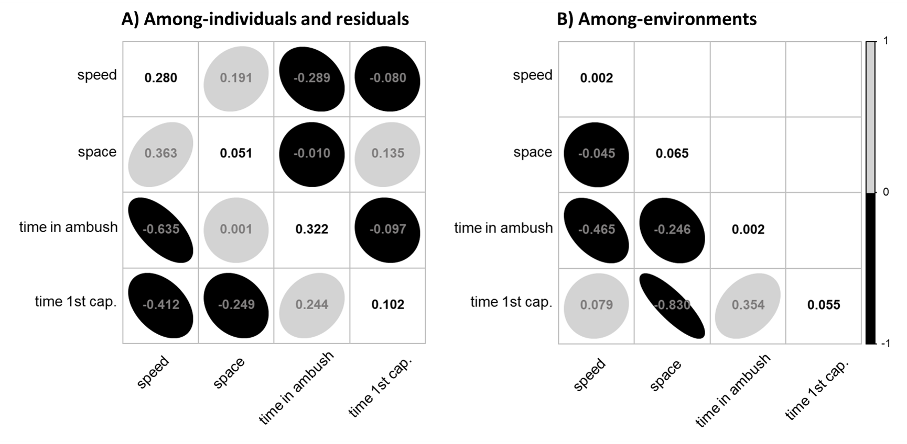

**Figure 2. Correlations between combinations of hunting behaviours and their ICCs.** We ran the model on a sample of 70 831 matches from 2 171 players who played in 27 different game environments, using different 15 avatars. The sample size of each parameter’s posterior distribution is 4000. Each correlation is computed using the BLUPs of the random effect of interest. For each panel, the ICC of the trait is displayed on the diagonal. Black and gray circles are negative and positive correlations respectively. **A)** The left panel shows among-individual behavioural correlations on the lower off-diagonal, and residual within-individual behavioural correlations on the upper off-diagonal. **B)** The right panel displays among-environment behavioural correlations on the lower off-diagonal. The hunting behaviour names were abbreviated for simplicity

### (ii) Correlations between hunting behaviours

As we expected, the predators’ average travel speed and proportion of time spent guarding(ra0,y1a0,y3 305 [95% CI] = - 0.649 [ - 0.681, - 0.608]) were negatively correlated, where faster predators spent less time guarding prey (Fig. 1a, upper off-diagonal). There were no strong among-individual correlations for other trait combinations. At the residual within-individual level, we detected a small positive correlation 308 between travel speed and the rate of space covered (re0,y1e0,y2 ) and a [95% CI] = 0.168 [0.163, 0.177] 309 negative correlation between travel speed and proportion of time spent guarding prey (re0,y1e0,y3 [95% CI] = 310 -0.291 [ - 0.298, - 0.284]) (Fig. 1a, lower off-diagonal). Hence, matches in which a predator was faster 311 were also matches in which the predator covered space at a faster rate, and spent less time guarding prey. 312 Finally, we did not detect among-environment behavioural correlations for any trait combination (Fig. 1b).

## (b) Effect of hunting behaviour on prey capture

### (i) Relationship between predator behaviour and hunting success

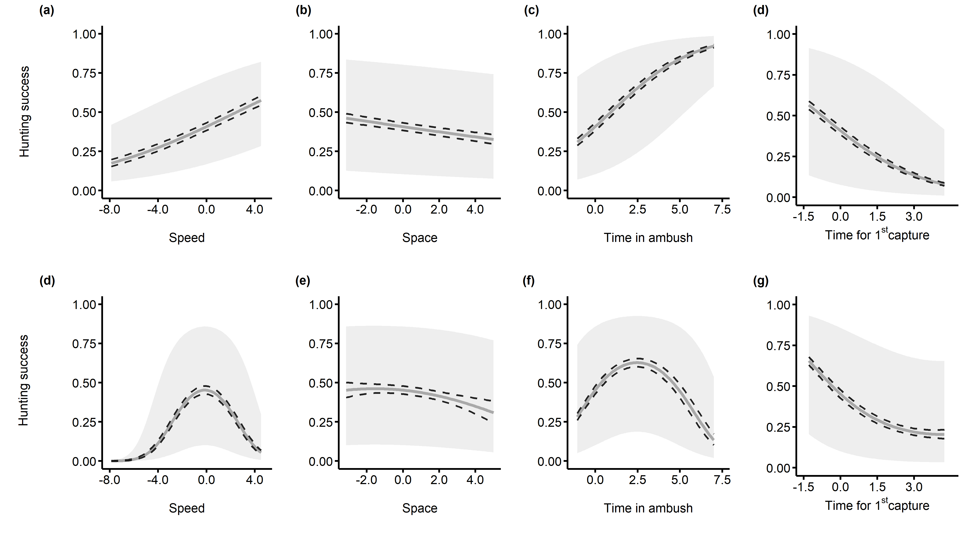

**Figure 3. Effect of predator hunting behaviour on prey capture.** The probability of capturing all four prey is on the y axis for all panels, and the standardized hunting behaviour is on the x axis. The black dashed lines represent 95% credibility intervals for the predicted values, and the gray band represents the 95% prediction intervals for each trait value. We ran the model on a sample of 70 831 matches from 2 171 players who played in 27 different game environments. The sample size of each parameter’s posterior distribution is x. **(a)**, **(b)**, **(c)** Linear relationship. **(d)**, **(e)**, **(f)** Quadratic relationship.

### (ii) Correlated effects of predator and prey behaviour on predator hunting success

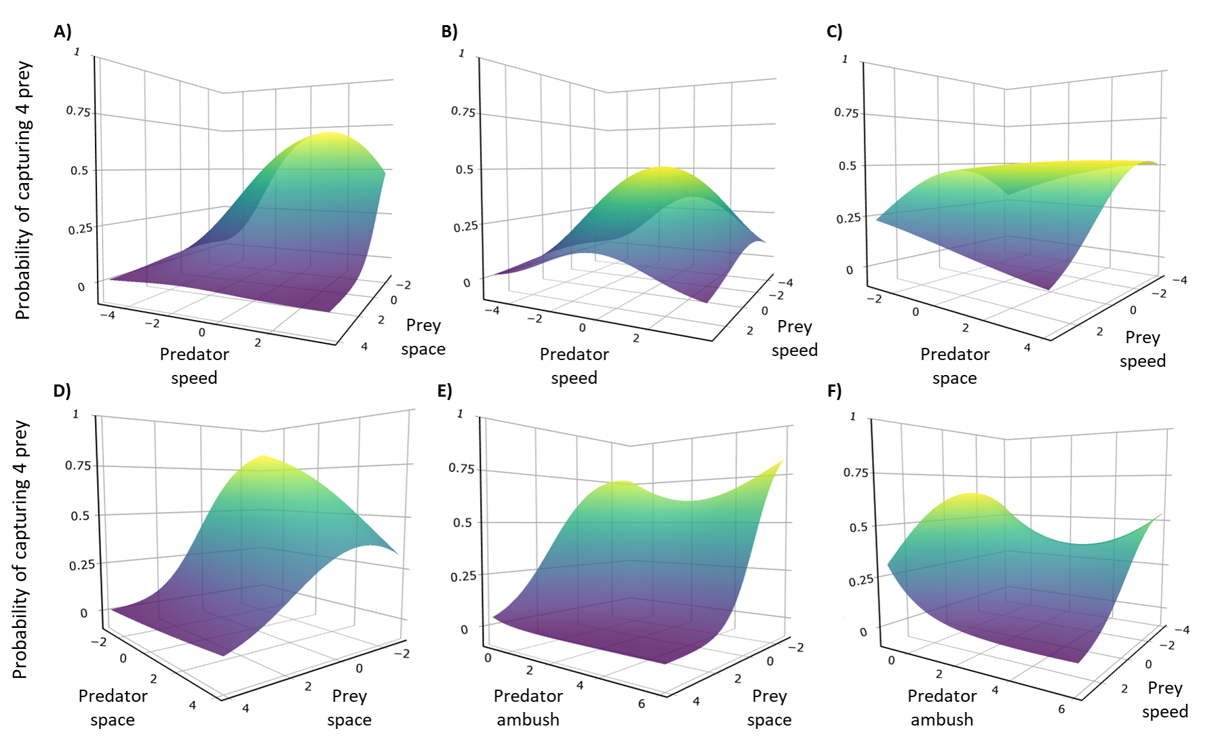

**Figure 4. Correlated effect of predator and prey behaviour on predator hunting success.** We ran the model on a sample of 70 831 matches from 2 171 players who played in 27 different game environments. The sample size of each parameter’s posterior distribution is x. **A)** Predator speed and. **B)** Predator and prey. **C)** blabla. **D)** blabla. **E)** blabla. **F)** blabla. EXPLAIN TRAIT Abbreviations

(8 pages double spaced left for AmNat)

# Acknowledgements:

We thank Behaviour Interactive for generous access to their data, and members of the Rover Team (Julien Céré, Guillaume Bergerot, Jean-Baptise Le Meur, Nicholas Robitaille) in the company for inputs on the preliminary results. We would also like to thank Denis Réale, Renata G. Ferreira, Hassen Allengue, Hélène Dion-Phénix, Katherine Vandal, Joël Jameson, Elouana Gharnit, Hannes Schraft, Laura Chouinard-Thuly, Noémie Lafortune, Louis-Philippe Toupin, Mélodie de Jaham, and Daphné Bourget from the GRECA at UQAM for their insightful comments and suggestions on the whole research process which led to a better version of this manuscript.

# Author contributions:

MFF and POM conceived the study. MFF collected the data, conducted the analyses, and led the writing of the manuscript. All authors contributed to revisions and gave their final approval for the present manuscript.

# Competing interests:

The authors declare no competing interests

# Grant information:

This project was funded by the Mitacs Accelerate Grant (#IT12054) through a partnership with Behaviour Interactive and Université du Québec à Montréal.

# Data availability statement:

We could not openly share the data on open science/data web platforms due to privacy restrictions. However, upon reasonable request, we can provide the data used to conduct our analyses. In addition, the project’s R scripts and results are available on this GitHub repository: <https://github.com/quantitative-ecologist/videogame_hunting_tactics-Rscripts>.

# References

Ahmad, M.A., Shen, C., Srivastava, J. & Contractor, N. (2014). On the Problem of Predicting Real World Characteristics from Virtual Worlds. In: *Predicting Real World Behaviors from Virtual World Data*, Springer Proceedings in Complexity (eds. Ahmad, M.A., Shen, C., Srivastava, J. & Contractor, N.). Springer International Publishing, Cham, pp. 1–18.

Araújo, M.S., Bolnick, D.I. & Layman, C.A. (2011). The ecological causes of individual specialisation. *Ecology Letters*, 14, 948–958.

Arthur, B., Hindell, M., Bester, M.N., Oosthuizen, W.C., Wege, M. & Lea, M.-A. (2016). South for the winter? Within-dive foraging effort reveals the trade-offs between divergent foraging strategies in a free-ranging predator. *Functional Ecology*, 30, 1623–1637.

Balicer, R.D. (2007). Modeling Infectious Diseases Dissemination Through Online Role-Playing Games. *Epidemiology*, 18, 260–261.

Barbe, L., Mony, C. & Abbott, B.W. (2020). Artificial Intelligence Accidentally Learned Ecology through Video Games. *Trends in Ecology & Evolution*, 35, 557–560.

Belgrad, B.A. & Griffen, B.D. (2016). Predator–prey interactions mediated by prey personality and predator hunting mode. *Proceedings of the Royal Society B: Biological Sciences*, 283, 20160408.

Bowen, W.D., Tully, D., Boness, D.J., Bulheier, B.M. & Marshall, G.J. (2002). Prey-dependent foraging tactics and prey profitability in a marine mammal. *Marine Ecology Progress Series*, 244, 235–245.

Brodie, E.D., Moore, A.J. & Janzen, F.J. (1995). Visualizing and quantifying natural selection. *Trends in Ecology & Evolution*, 10, 313–318.

Butler, M.A. (2005). Foraging mode of the chameleon, Bradypodion pumilum: A challenge to the sit-and-wait versus active forager paradigm? *Biological Journal of the Linnean Society*, 84, 797–808.

Bürkner, P.-C. (2017). Brms: An R Package for Bayesian Multilevel Models Using Stan. *Journal of Statistical Software*, 80, 1–28.

Carneiro, A.P.B., Bonnet-Lebrun, A.-S., Manica, A., Staniland, I.J. & Phillips, R.A. (2017). Methods for detecting and quantifying individual specialisation in movement and foraging strategies of marine predators. *Marine Ecology Progress Series*, 578, 151–166.

Carter, A.J., Feeney, W.E., Marshall, H.H., Cowlishaw, G. & Heinsohn, R. (2013). Animal personality: What are behavioural ecologists measuring? *Biological Reviews*, 88, 465–475.

Chang, C.-c., Teo, H.Y., Norma-Rashid, Y. & Li, D. (2017). Predator personality and prey behavioural predictability jointly determine foraging performance. *Scientific Reports*, 7, 40734.

Cooper, W.E. (2005). The foraging mode controversy: Both continuous variation and clustering of foraging movements occur. *Journal of Zoology*, 267, 179–190.

Courbin, N., Besnard, A., Péron, C., Saraux, C., Fort, J. & Perret, S. *et al.* (2018). Short-term prey field lability constrains individual specialisation in resource selection and foraging site fidelity in a marine predator. *Ecology Letters*, 21, 1043–1054.

Dall, S.R.X. & Griffith, S.C. (2014). An empiricist guide to animal personality variation in ecology and evolution. *Front. Ecol. Evol.*, 2.

Dingemanse, N.J. & Dochtermann, N.A. (2013). Quantifying individual variation in behaviour: Mixed-effect modelling approaches. *Journal of Animal Ecology*, 82, 39–54.

Dingemanse, N.J. & Wright, J. (2020). Criteria for acceptable studies of animal personality and behavioural syndromes. *Ethology*, 126, 865–869.

Donihue, C.M. (2016). Aegean wall lizards switch foraging modes, diet, and morphology in a human-built environment. *Ecology and Evolution*, 6, 7433–7442.

Gerritsen, J. & Strickler, J. (1977). Encounter probabilities and community structure in zooplankton: A mathematical model. *Journal of the Fisheries Board of Canada*, 34.

Glaudas, X., Glennon, K.L., Martins, M., Luiselli, L., Fearn, S. & Trembath, D.F. *et al.* (2019). Foraging mode, relative prey size and diet breadth: A phylogenetically explicit analysis of snake feeding ecology. *Journal of Animal Ecology*, 88, 757–767.

Griffen, B.D., Toscano, B.J. & Gatto, J. (2012). The role of individual behavior type in mediating indirect interactions. *Ecology*, 93, 1935–1943.

Harrison, X.A. (2015). A comparison of observation-level random effect and Beta-Binomial models for modelling overdispersion in Binomial data in ecology & evolution. *PeerJ*, 3, e1114.

Heithaus, M.R., Dill, L.M. & Kiszka, J.J. (2018). Feeding strategies and tactics. In: *Encyclopedia of Marine Mammals (Third Edition)* (eds. Würsig, B., Thewissen, J.G.M. & Kovacs, K.M.). Academic Press, pp. 354–363.

Helfman, G.S. (1990). Mode selection and mode switching in foraging animals. In: *Advances in the Study of Behavior* (eds. Slater, P.J.B., Rosenblatt, J.S. & Beer, C.). Academic Press, pp. 249–298.

Hertel, A.G., Niemelä, P.T., Dingemanse, N.J. & Mueller, T. (2020). A guide for studying among-individual behavioral variation from movement data in the wild. *Movement Ecology*, 8.

Huey, R.B. & Pianka, E.R. (1981). Ecological consequences of foraging mode. *Ecology*, 62, 991–999.

Inoue, T. & Marsura, T. (1983). Foraging strategy of a mantid, Paratenodera angustipennis S.: Mechanisms of switching tactics between ambush and active search. *Oecologia*, 56, 264–271.

James, P.L. & Heck Jr., K.L. (1994). The effects of habitat complexity and light intensity on ambush predation within a simulated seagrass habitat. *Journal of Experimental Marine Biology and Ecology*, 176, 187–200.

Kersch‐Becker, M.F., Grisolia, B.B., Campos, M.J.O. & Romero, G.Q. (2018). Community-wide responses to predation risk: Effects of predator hunting mode on herbivores, pollinators, and parasitoids. *Ecological Entomology*, 43, 846–849.

Kobler, A., Klefoth, T., Mehner, T. & Arlinghaus, R. (2009). Coexistence of behavioural types in an aquatic top predator: A response to resource limitation? *Oecologia*, 161, 837–847.

Laurel, B.J. & Brown, J.A. (2006). Influence of cruising and ambush predators on 3-dimensional habitat use in age 0 juvenile Atlantic cod Gadus morhua. *Journal of Experimental Marine Biology and Ecology*, 329, 34–46.

Lima, S.L. (2002). Putting predators back into behavioral predator–prey interactions. *Trends in Ecology & Evolution*, 17, 70–75.

Lofgren, E.T. & Fefferman, N.H. (2007). The untapped potential of virtual game worlds to shed light on real world epidemics. *The Lancet Infectious Diseases*, 7, 625–629.

McCoy, E.D. & Bell, S.S. (1991). Habitat structure: The evolution and diversification of a complex topic. In: *Habitat Structure: The physical arrangement of objects in space*, Population and Community Biology Series (eds. Bell, S.S., McCoy, E.D. & Mushinsky, H.R.). Springer Netherlands, Dordrecht, pp. 3–27.

McGhee, K.E., Pintor, L.M. & Bell, A.M. (2013). Reciprocal behavioral plasticity and behavioral types during predator-prey interactions. *The American Naturalist*, 182, 704–717.

McLaughlin, R.L. (1989). Search modes of birds and lizards: Evidence for alternative movement patterns. *The American Naturalist*, 133, 654–670.

Michel, M.J. & Adams, M.M. (2009). Differential effects of structural complexity on predator foraging behavior. *Behavioral Ecology*, 20, 313–317.

Miles, D.B., Losos, J.B. & Irschick, D.J. (2007). Morphology, performance, and foraging mode. In: *Lizard Ecology* (eds. Miles, D.B., McBrayer, L.B. & Reilly, S.M.). Cambridge University Press, Cambridge, pp. 49–93.

Miller, J.R.B., Ament, J.M. & Schmitz, O.J. (2014). Fear on the move: Predator hunting mode predicts variation in prey mortality and plasticity in prey spatial response. *Journal of Animal Ecology*, 83, 214–222.

Nakagawa, S. & Cuthill, I.C. (2007). Effect size, confidence interval and statistical significance: A practical guide for biologists. *Biological Reviews*, 82, 591–605.

Nakagawa, S., Johnson, P.C.D. & Schielzeth, H. (2017). The coefficient of determination R2 and intra-class correlation coefficient from generalized linear mixed-effects models revisited and expanded. *Journal of The Royal Society Interface*, 14, 20170213.

Nakagawa, S. & Schielzeth, H. (2010). Repeatability for Gaussian and non-Gaussian data: A practical guide for biologists. *Biological Reviews*, 85, 935–956.

Niemelä, P.T. & Dingemanse, N.J. (2014). Artificial environments and the study of “adaptive” personalities. *Trends in Ecology & Evolution*, 29, 245–247.

Oultram, S. (2013). Virtual plagues and real-world pandemics: Reflecting on the potential for online computer role-playing games to inform real world epidemic research. *Medical Humanities*, 39, 115–118.

Perry, G. (1999). The evolution of search modes: Ecological versus phylogenetic perspectives. *The American Naturalist*, 153, 98–109.

Perry, G., Werner, Y.L., Lampl, I., Rothenstein, D., Sivan, N. & Lerner, A. *et al.* (1990). Foraging mode in lacertid lizards: Variation and correlates. *Amphibia-Reptilia*, 11, 373–384.

Pettorelli, N., Hilborn, A., Duncan, C. & Durant, S.M. (2015). Chapter Two - Individual variability: The missing component to our understanding of predator–prey interactions. In: *Advances in Ecological Research*, Trait-Based Ecology - From Structure to Function (eds. Pawar, S., Woodward, G. & Dell, A.I.). Academic Press, pp. 19–44.

Phillips, R.A., Lewis, S., González-Solís, J. & Daunt, F. (2017). Causes and consequences of individual variability and specialization in foraging and migration strategies of seabirds. *Marine Ecology Progress Series*, 578, 117–150.

Preisser, E.L., Orrock, J.L. & Schmitz, O.J. (2007). Predator hunting mode and habitat domain alter nonconsumptive effects in predator–prey interactions. *Ecology*, 88, 2744–2751.

Robinson, S.K. & Holmes, R.T. (1982). Foraging behavior of forest birds: The relationships among search tactics, diet, and habitat structure. *Ecology*, 63, 1918–1931.

Romero, G.Q. & Koricheva, J. (2011). Contrasting cascade effects of carnivores on plant fitness: A meta-analysis. *Journal of Animal Ecology*, 80, 696–704.

Ross, T.L., Castronova, E. & Knowles, I. (2015). Virtual Worlds as Laboratories. In: *Emerging Trends in the Social and Behavioral Sciences*. American Cancer Society, pp. 1–15.

Sargeant, B.L., Wirsing, A.J., Heithaus, M.R. & Mann, J. (2007). Can environmental heterogeneity explain individual foraging variation in wild bottlenose dolphins (Tursiops sp.)? *Behav Ecol Sociobiol*, 61, 679–688.

Scharf, I., Nulman, E., Ovadia, O. & Bouskila, A. (2006). Efficiency evaluation of two competing foraging modes under different conditions. *The American Naturalist*, 168, 350–357.

Schmitz, O. (2017). Predator and prey functional traits: Understanding the adaptive machinery driving predator–prey interactions. *F1000Res*, 6, 1767.

Schmitz, O.J. (2008). Effects of predator hunting mode on grassland ecosystem function. *Science*, 319, 952–954.

Smith, B.R. & Blumstein, D.T. (2010). Behavioral types as predictors of survival in Trinidadian guppies (Poecilia reticulata). *Behavioral Ecology*, 21, 919–926.

Tinker, M.T., Bentall, G. & Estes, J.A. (2008). Food limitation leads to behavioral diversification and dietary specialization in sea otters. *PNAS*, 105, 560–565.

Toscano, B.J., Gownaris, N.J., Heerhartz, S.M. & Monaco, C.J. (2016). Personality, foraging behavior and specialization: Integrating behavioral and food web ecology at the individual level. *Oecologia*, 182, 55–69.

Toscano, B.J. & Griffen, B.D. (2014). Trait-mediated functional responses: Predator behavioural type mediates prey consumption. *Journal of Animal Ecology*, 83, 1469–1477.

Wasiolka, B., Blaum, N., Jeltsch, F. & Henschel, J. (2009). Behavioural responses of the lizard Pedioplanis l. Lineoocellata to overgrazing. *Acta Oecologica*, 35, 157–162.

Wignall, A.E. & Taylor, P.W. (2008). Alternative predatory tactics of an araneophagic assassin bug (Stenolemus bituberus). *acta ethol*, 12, 23.

Wolf, M. & Weissing, F.J. (2012). Animal personalities: Consequences for ecology and evolution. *Trends in Ecology & Evolution*, 27, 452–461.